# MKTG3501 MARKETING STRATEGY

**Outline Structure of Industry Marketing Project**

This should give you an idea of the sort of things you need to put into the final report. **Due the variety of organisations and the differing issues they face this outline should only be taken as a recommendation not a set of prescriptive guidelines. There may be points listed that won’t apply to your project and others which will be needed that I haven’t included here so feel free to modify this to suit your own project.**

**General notes:**

I don’t expect a lot of academic referencing or definitions (*e.g. Hume (2015) has defined segmentation as…*) but I do want to see good justification for everything you use or recommend. Make it clear to the client that you know what you are talking about. This may mean your secondary sources are reports, abs statistics, web advice, blogs and more.

This is not an academic essay so break the report up with headings, pictures, tables etc. The key thing to keep in mind is how easy it will be for the client to read and make sense of and how easy is it for the reader to identify the key points and recommendations you are making.

**Cover page**

This is not an academic essay. It is a business report so should look professional. It is a branding opportunity for your skills and ability. All reports need a cover page. Include your own company’s branding as well as the client’s. State what the report is for (the title). Include your names as consultants (again another opportunity to market yourself).

**WORD LIMIT: 5000 +/- 10%**

**Executive Summary**

The current report is to solve a marketing/business related problem and offer recommendations to adjust the current marketing strategy and develop a project solution. Our chosen business for this report is Audeara headphones. Audeara is a recent start-up company that creates tailored headphones by conducting a hearing test in order to “tailor your sound”. Audeara’s startup objective was to have the world's first full fidelity headphones with tailored sound for every consumer. Audeara offered this unique product from design and innovation, to a premium headphone that bring the joy of music to anyone seeking quality sound, regardless of their hearing capabilities. Audeara current market positioning is as a market nicher, with small however growing rate of sales. Their current market is split between two main segments; males aged from 25-35 and disabled people with a degree of hearing loss. Therefore, our business problem is to offer recommendation to help audeara gain a greater share of the market by attracting millennials – more specifically, university students. With Audeara having to compete against market leaders such as Sony, Bose and Beats we have come up with three key recommendation, we believe will help Audeara’s concern of attracting university students. We believe the key recommendations to addressing their marketing problem is by collaborating with myunidays to offer a 10% discount, bring Audeara product to JB HI FI for more coverage, while also offering afterpay as a solution to the high market price. In addition, we recommend for Audera to set up testing booths in music festivals to increase brand awareness and trust. From our key recommendations we have also noticed limitations that may act as a barrier for the success of Audeara. These limitations consists of the current existing market share already largely dominated by market leaders, price acceptance as well as uncertainty. The recommendations and limitations will be discussed in further detail below.

**Table of contents**

**1.0. Company / organisation overview - Haley**

Audeara is a recent start-up company that creates headphones with an inbuilt hearing test to follow their mission statement of “test your hearing, tailor your sound”. The company tailors the sound for each person based on two principles: every person hears differently, and every person hears differently in each ear. With these headphones, users will be able to use the inbuilt medical audiogram to monitor how their hearing changes over time and continue to ensure that their hearing profile is being used to experience the true quality of their music. Audeara have a vision of improving the way that people experience sound and developing products to improve hearing health. Their objective is to have the world’s first full fidelity headphones with sound tailored perfectly to each user, allowing them to hear notes they didn’t know they were missing, find new parts in their favourite songs, and continually monitor their hearing. Having fulfilled this objective, Audeara are now working towards a greater share of the market for headphones.

***SOURCE: https://www.kickstarter.com/projects/1986358006/audeara-headphones-that-deliver-perfect-sound-alw*a**

**2.0. Problem recognition - Haley**

Audeara are currently working towards gaining a greater share of the market and are particularly interested in attracting millennials – more specifically, university students. Clearly, they have some huge competition, with big players like Sony, Bose and Beats already dominating the market for headphones. One of the main concerns for Audeara is their goal of attracting university students and how to position themselves against these rivals to become a preference for the desired target market. As their main source of competitive advantage is the way that their products care for and are tailored to your hearing, they need to be able to stress the importance of this. This can become a problem when the millennial attitude for such health issues is often ‘we don’t care’ or ‘it isn’t affecting me right now’. Thus, Audeara want to know how they can get their message across to the current target market of university students. In addition, how they can attract and influence them to buy their products over already dominating competitors in this highly rivalrous industry.

We believe that Audeara’s problem with attracting university students and millennials may be a symptom of lack of brand awareness and trust. This can be seen through their presence online in comparison to other major headphones brands. For example: on Facebook, Audeara have around 18,000 likes, whereas Bose, Sony and beats have 4 million, 7.8 million and 8.8 million respectively. Instagram returns similar findings with Audeara obtaining 3,600 followers, whereas Bose, Sony and Beats obtain 622,000, 6.3 million and 4.2 million respectively. However, it is important to consider that some of these companies have a considerably larger range of products, have been around for a lot longer, and have a larger reputation in general compared to Audeara.

When consumers search for ‘headphones’ in Google, the first brand google recommends is Bose, followed by Beats, Sennheiser, Nuraphone, Apple, and Sony (this is not including results returned for stores and places to purchase headphones). Furthermore, these brands have a widespread availability, and are able to be purchased in stores including JB Hi-Fi, the Apple store, and Harvey Norman, whereas Audeara is exclusively purchased online. We believe that these factors may be contributing to a lack of brand awareness which, in turn, is leading to lower levels of trust, comprehension, and purchase intention from their target market of university students. Therefore, building brand awareness and strategic positioning will be the major focus to solve the problem of attracting university students and driving a greater share of the market.

**3.0. Situation Analysis**

**3.1. Internal analysis - Tina**

1. **Mission**

Audeara has revolutionized the listening experience by supplying the world’s first full fidelity headphones with a built-in hearing test. The headphones were first envisioned as a medical device to assist people suffering from hearing loss, but as the product and company evolved, Audeara wanted to cater to masses, and developed a product suitable for anyone seeking quality sound. Sleek, safe and stylish - the A-01 headphones are a high quality audio device that users can personalize to their own hearing profile. Audeara fulfils their mission by bringing the joy of perfect sound to all people, regardless of their hearing capabilities.

1. **Resources**

One of the main resources needed for Audeara is the manufacturing company that produces the headphones. Audeara outsources the manufacturing process overseas in Shenzhen, China to produce their innovative headphones. As an innovative headphone producer, Audeara set up their main office in Newstead in Brisbane for R&D, Tech Support, Customer Relationship Management, and operations of business. Partnership is also an important resource for Audeara. They are currently partnered with Attune hearing - a professional audiologist body that have strong reputations in the industry. This retail partnership enables Audeara to gain traction and credibility for future investments and partnerships. In addition to this, access to and relevant knowledge of digital marketing is essential to get their brand to the front of consumers mind with potential purchase intent. Lastly, an essential aspect that drives the company’s success is their employees. They are the core to ensure the Audeara’s operations flow smoothly and convey a consistent brand image to consumers and potential customers.

1. **Offering**

Audeara design and develop innovative, premium headphones that bring the joy of music to anyone seeking quality sound, regardless of their hearing capabilities. The headphones make music better - not louder - and provide perfect sounds. The company has promoted the importance of hearing health as everyone has a certain degree of hearing loss. More and more people are losing their hearing, with statistics from the World Health Organization indicating that 1.1 billion young people (aged between 12-35 years) are at risk of hearing loss due to exposure to noise in recreational settings **(reference 1)**. This calibrated set of Bluetooth headphones has an in-built hearing test that could be operated by any smartphone to tailor the sounds to match with the individual hearing profile to protect the user’s hearing. In addition, Audeara is also one of the disability service providers under the National Disability Insurance Scheme (NDIS). Disabled people with certain degrees of hearing loss are eligible to get a pair of Audeara headphones for free through reimbursement by the government.

Reference 1:

<http://www.who.int/news-room/fact-sheets/detail/deafness-and-hearing-loss>

**3.2. External analysis:**

**3.2.1 PESTEL analysis - Tina**

Table 1.1

| **Demographic Trends** | According to the World Health Organization, there are currently 1.1 billion young people worldwide (aged between 12 - 35 years) at risk of hearing loss due to exposure to noise in recreational settings (**reference 6**). In particular, one in six Australians suffer from some degree of hearing loss. Only a quarter of people could benefit from a hearing aid due to a variety of reasons and financial constraints. There is an average of seven years between a person needing help from a hearing aid and actually seeking help from a audiologist. A lot of these cases of hearing loss are actually preventable.  **reference 6)** Hearing loss symptoms is an inconveniences to the quality of many people’s daily life. Therefore, hearing loss prevention has gradually become an important initiative. Audeara is motivated by the significance of hearing loss, and they work towards preventing and helping those affected by it to manage their hearing loss. Audeara headphones provide consumers with a beneficial health-conscious incentive to protect their hearing and this could potentially lead to consumer expansions. |
| --- | --- |
| **Technology** | According to the Grand View research in 2015, advances in earphone & headphone technology are the critical factors attributing increased product sales **(reference 1)**. The most impressive advancement in the field of audio technology are the noise-cancellation feature and wireless connectivity from Bluetooth feature, particularly tapping into the minds of consumers. In addition to this, advanced sound quality and personalization effects also play a pivotal part in getting the attention of consumers. Over the past few years, these features have emerged as core trends, and manufacturers have emphasized on developing these key features to align with consumers’ needs for wireless products. (**reference 2**) |
| **Political /Legal** | People who meet the NDIS access requirements are referred to as participants. Participants receive funding, support, and an individual plan from government. Disability service providers who meet certain benchmarks are eligible for reimbursement from the government. (**reference 3**)  Intellectual patents protect genuine business assets and are vital to innovative products. it is the key to the success and profitability of the businesses. Audeara’s full fidelity headphones are protected by an intellectual patent in Australia. This may be seen as a source of competitive advantage for the company. (**reference 4**) |
| **Economic** | According to the Grand View research, the global earphones and headphones market size was valued at 8.7 billion USD in 2015 (**reference 1**). Technological advancement in the headphone industry continues to fuel market growth. Therefore, it is an attractive market for existing competitors. In addition to this, with the rise of disposable personal income (**refer to appendix 1)**, households will have more money either to save or spend, which may lead to growth in consumption. (**reference 5**)  The prices of different brands of headphones with similar features are listed below on table 1.3. This has been derived from Audeara internal marketing analysis. |
| **Socio-cultural** | According to the Grand View research, the current growth of the earphone and headphone industry is not a fad, rather, it’s the outcome of the technological advancements in the industry (**reference 1**). The rise in this adoption is a result of more people being tethered to their smart devices, such as music players, mobiles, and tablets, etc. They use these devices for a significant portion of their day, commonly for listening to music, watching videos, and playing games. Today, a growing number of people are seen walking around with earphones or headphones, more so than in previous years, as the portability of music has completely evolved over the past few decades. A majority of customers also seek fashionable, sleek, and trendy products with their appliances. (**reference 1)** The future of these products is anticipated to rely on technology, physical appearance, and design that fits in with the customer’s values and promotes their individuality, which is also why “personalization” is used to attain the hearts (and purchases) of consumers. These sleek products exhibit the ability to penetrate all the existing price segments: low-range, mid-range, and high-range products. |

Sources:

Source 1:

<https://www.grandviewresearch.com/industry-analysis/earphone-and-headphone-market>

Source 2:

<https://www.lifewire.com/stereo-home-audio-tech-trends-3134846>

Source 3:

<https://www.ndis.gov.au/providers.html>

Source 4:

<https://www.nibusinessinfo.co.uk/content/advantages-protecting-intellectual-property>

Source 5:

<https://tradingeconomics.com/australia/disposable-personal-income>

Source 6:

<http://www.who.int/news-room/fact-sheets/detail/deafness-and-hearing-loss>

**3.2.2 SWOT analysis - Maddy**

A swot analysis is the framework for identifying and analysing the internal (strengths and weakness) and external factors (opportunities and threats) that impact the businesses profitability and competitiveness. The following table will analyse the main targets for the business, Audeara, by convert their weaknesses and threats into future advantages and by finding their competitive advantage from assessing the strengths and opportunities

Table 1.2

| Strengths   * world’s first full fidelity headphones with a built-in hearing test * Designed by Doctors & engineers as a medical device to assist people suffering from hearing loss * strong potential for brand loyalty ensured through high quality tailored sound. * features like active noise cancelling, Bluetooth, wired capability, low latency streaming and hands-free calling * Innovative & highly sophisticated product | Weakness   * Lack of brand awareness and trust, therefore effective marketing strategies should be put in place to create customers * 15 minute test in order to tailor your headphones can be a deterrent * customer may consider the headphone to have a high market price, without knowing the value (similar prices) * the current product range audeara offers is considerably narrow compared to competitors * Audeara only operates online due to high cost for rent |
| --- | --- |
| Opportunity   * due to the high market price, audeara can offer consumers the option of after pay. * targeting university students through outlets such as ‘Unidays’ with special promotions/discount to encourage purchases * to open a store in the near future to increase exposure to consumers and potentially add to brand trust. | Threats  - Large competitors who have already established brand awareness and trust ie, Sony and Beats  - Rising manufacturing costs, as Audeara’s main resources needed is outsourced from Shenzhen China  - other companies = larger range of product |

1. In summary, from the analysis conducted in table 1.1 it is highly recommended for the client to focus on the most important avenue; university students. By expanding their target market to university students through outlets such as unidays and offering afterpay as an incentive this will increase their opportunity of revenue. In addition, an increase in profit will help the start up business to transfer from only operating online to opening up a shop in the heart of brisbane near their head office. With these strategies set in place this will help increase brand trust and awareness for Audeara resulting in an increase in profit margin.

**3.2.3 Competitive Advantage. - MIKEY**

Just because Audeara is a small growing company, this does not mean that substantial competitive advantage doesn’t radiate throughout the firm. The fact that the company raised over $1000, 000 in the first hour of its Kickstarter campaign is a testament to this. An Audeara customer is someone who has recognised this value. They want more out of their listening experience than other consumers in the headphone market. Audeara customers truly believes that the product that the company provides outshines any of the other standard products on the market.

Table 1.3 compares Audeara’s A01 model with a number of its competitors through a number of criteria:

Table 1.3

| **Brand** | **Model** | **Threshold Hearing Test** | **Track Hearing Health** | **App** | | **B/T** | **ANC** | **Tailored Sound** | **Battery Life** | **RRP (AUD)** |
| --- | --- | --- | --- | --- | --- | --- | --- | --- | --- | --- |
|  |  |  |  | **Customisable / Controllable** | **Record user data** |  |  |  | **B/T + ANC** | $ |
| **Audeara** | A-01 | ✔ | ✔ | ✔ | ✔ | ✔ | ✔ | ✔ | 20 | 499 |
| **Nura** | Nura | x | x | ✔ | ✔ | ✔ | ✔ | ✔ | 20 | 429 |
| **EVEN** | H1 | ✔ | x | x | x | x | x | ✔ | 12 | 262 |
| H2 | ✔ | x | ✔ | x | ✔ | x | ✔ | 20 | 373 |
| **Nuheara** | IQBuds | x | x | ✔ | x | ✔ | ✔ | x | 4 | 399 |
| **SONY** | MDR-1000x | x | x | x | x | ✔ | ✔ | x | 20 | 699 |
| WH-1000MX2 | x | x | ✔ | x | ✔ | ✔ | x | 30 | 499 |
| **BOSE** | QC35 | x | x | ✔ | x | ✔ | ✔ | x | 20 | 499 |
| **PARROT** | Zik 3 | x | x | ✔ | x | ✔ | ✔ | x | 7.5 | 599 |
| **BEATS** | Studio Wireless | x | x | x | x | ✔ | ✔ | x | 12 | 479 |
| **SENNHEISER** | Momentum 2.0 | x | x | ✔ | x | ✔ | ✔ | x | 22 | 799 |
| **Audio Technica** | ATH-DSR9BT | x | x | x | x | ✔ | x | x | 20 | 899 |

As you can see here, Audeara’s model is the only one that includes tailored sound, threshold hearing testing and that tracks hearing health, showing how unique it is among the major players. With this in mind, the price can be acknowledged as being slightly above average but extremely good value for money.

Audeara’s business level strategy is that of a focused differentiation one. Simply: excellent quality at a slightly above average price. To fully encapsulate Audeara’s competitive advantage it is appropriate to identify their core capabilities and conduct a VRIN analysis

Table 1.4

| **Core Capability** | **Valuable?** | **Rare?** | **Costly to Imitate?** | **Non-substitutable?** |
| --- | --- | --- | --- | --- |
| **Tailor Made Sound** | Extremely | Not necessarily, however Audeara’s level of tailoring is very rare | Yes, it has medical professionals and years of hard work to reach this stage | Absolutely, it defines the brand |
| **Designed by Doctors origins**  **(**Brisbane based doctors, Dr. James Fielding and Dr. Chris Jeffery founded Audeara in 2014 to fill the gap in hearing technology) | Yes, this legitemises the techniques used to tailor the sound | Yes, it is not common for | Yes, you need the properly qualified people, both professionally and personally, from the beginning | Yes |
| **Australian Company** | Yes, high levels of disposable income = great domestic market | No | Can’t imitate at all | Yes, this means extra value and exceptional service will be provided to domestic customers here in Australia |
|  |  |  |  |  |

**Current Buyers…**

Overall the response continues to be positive. Customers continue to be amazed at the application of tailored sound within their headphones. There has been all-round praise for the accompanying Audeara app and its performance. Some prominent reviewers have echoed this sentiment:

“But in offering a highly personalized listening experience, and showing more consideration for your eardrums than many manufacturers, the Audeara A-01 headphones provide a level of care and customization that’s far ahead of the competition.”

* Henry St Leger, 2018, <https://www.techradar.com/au/reviews/audeara-a-01-review>

As well as this, the product is still in its infancy (as “A-01 model” suggests) and there is significant scope improvement in any growth areas that have been recognised.

**Potential Buyers…**

in the current target segment of millenials, will likely be music lovers. People that acknowledge the expertise in the production in today’s music and the complex and forever growing spread and precision of sounds that producers around the world incorporate into music today. Essentially the jump from listening with run of the mill headphones to Audeara’s product, can be likened to the difference between the speakers in your laptop and the speakers in your car, there is no comparison.

These types of headphones are a luxury item, and are something that a customer hopes to only have to purchase very rarely in their life with the understanding that it requires a solid financial contributing. We are confident that the customer’s over-arching search for true value will lead them to Audeara’s product.

**3.2.4. Competitor analysis - MIKEY**

The global headphone market is split into three segments:

1. In-ear headphones (like the apple earpods)

2. On-ear headphones

3. Over-ear headphones

The estimated 2016 global market share between these 3 segments was:

In-ear = 56.44%

On-ear = 23.33%

Over-ear = 20.23%

(TechNavio, 2016) <https://www.businesswire.com/news/home/20161229005052/en/Rapid-Growth-Sports-Headphones-Drive-Headphones-Market>

Due to making only an over-ear product, you could say that Audearea’s biggest competitor is the in-ear market. However, while over-ear headphones quality and performance still far outweighs the other two segments, there is a risk of losing market share as these in-ear and on-ear products continue to improve and develop.

As far as actual brands are concerned, Beats (now in conjunction with Apple) are the clear market leaders. This can be seen in the following figure depicting the US wireless headphone market.

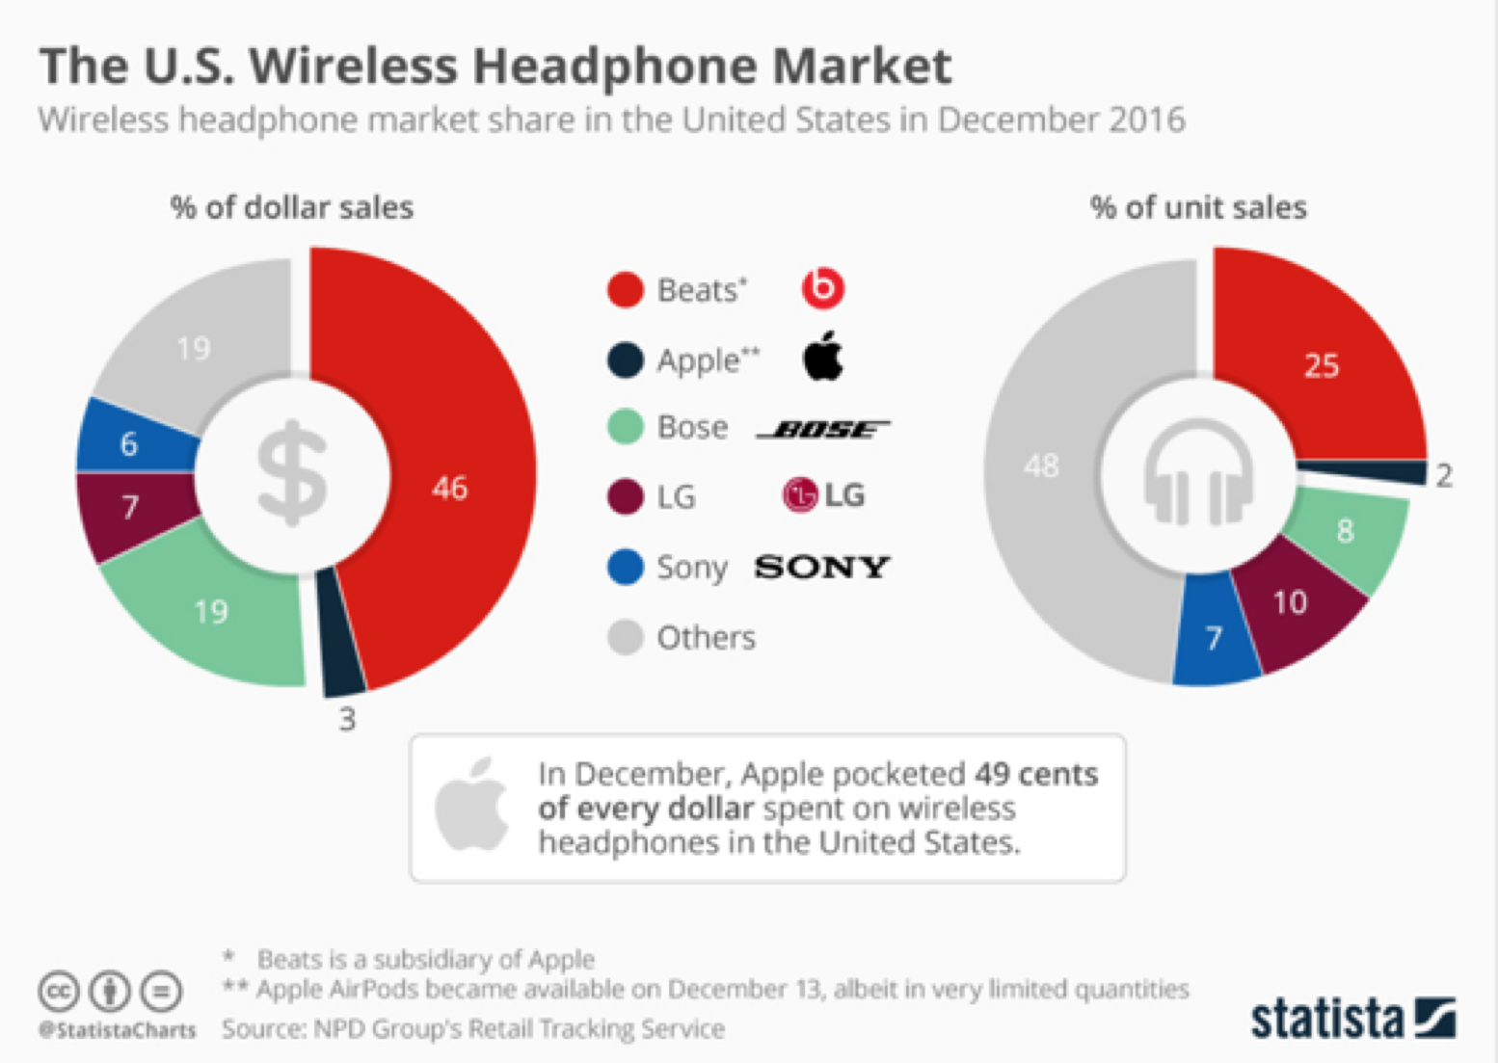

[**https://www.statista.com/chart/7993/headphone-market-share/**](https://www.statista.com/chart/7993/headphone-market-share/)

**Competitors:**

**International:**

Beats by Dre:

* Beats are a clear market leader and have continued to thrive after being purchased by Apple for US$3 billion in 2014
* Innovative Designs
* Price levels range from $140 to $500
* Incredible brand recognition (anchored by the success of Dr. Dre and celebrity endorsement)
* Striving for monopoly

BOSE and Sony

* Both are powerful global companies, however are market followers to Beats in the headphone segment
* BOSE prices = $320 - $500
* BOSE had limited but high quality options = Differentiation strategy
* Sony prices = $50 - $500
* Sony offers a much larger range than any of the other major brands, as well as a number of low-cost options as well as premium products = Cost Leadership AND differentiation strategy

**Domestic:**

Nuheara:

* Also launched also year and set an Australian kickstarter record last year of $1.8 million.
* Market Nicher
* Prices = $400 - $650
* Complex In-Ear focus - IQBuds product that adapt to your hearing profily (tailored sound)
* Very similar focused differentiation strategy to Audeara, with an in-ear focus rather than over-ear.
* Audeara’s main domestic competition

Nura:

* Launched last year with $1 million in crowd-funding
* Market Follower to global brands
* Over Ear Focus
* One product: Nuraphone = $500
* Differentiation strategy

Overall, it would be wise for Audeara to focus majority of their business-level strategies on a domestic level. They are simply not ready to be taking on global powerhouses like Beats and Apple or BOSE and Sony. However, on a domestic level, Audeara is positioned extremely well there is no glaringly obvious reason why Audeara can’t strive to take down the Australian competition and be the clear market leader.

**4.0. Market research**

**4.1. Target Market - Tina**

**Existing target market:**

Audeara’s current target market and common consumers can be divided into two segments. Firstly, males aged from 25 - 35 that seek well-defined music and sound quality. These consumers are heavily interested in gaming and music, and thus find value in sound quality. The second segment Audeara currently target and serve is disabled people with some degree of hearing loss in Australia. As previously mentioned, Audeara is one of the disability service providers under the National Disability Insurance Scheme. People who meet a certain criteria and degree of hearing loss are eligible to receive a pair of Audeara headphones for free through government reimbursement. Through this, Audeara has formed a retail partnership with Attune hearing as a distribution avenue for these customers. In the future, Audeara will continue working with more professional audiologist bodies to expand their market shares in Australia. Therefore, these consumers will not be the focus of this report.

**Intended target Market:**

Our intended target segment in this report is the millennial generation aged from 18 - 24 years, as they have the longer-term potential for profits. More specifically, Audeara has asked for a focus on university students in this target market. Millenials are constantly and increasingly exposed to noise pollutions as a result of participation in recreational activities including music festivals and concerts, clubbing, frequent attendance at bars, listening to music at high volumes and more. Therefore, are more affected by the potential of hearing loss and other hearing issues than other target markets. Audeara believe they may be able to prevent some of these effects and genuinely benefit this group of consumers.

**4.2. Positioning - Mikey**

Auderea is currently positioned as a market “nicher” with a small but growing rate of sales/market share and a significant focus on being a feature specialist in their commitment to tailoring their products. Audeara is positioned behind global powerhouses and market leaders such as Beats, however consumers are slowly recognising the value that the company provides.

Price vs capabilities positioning map:

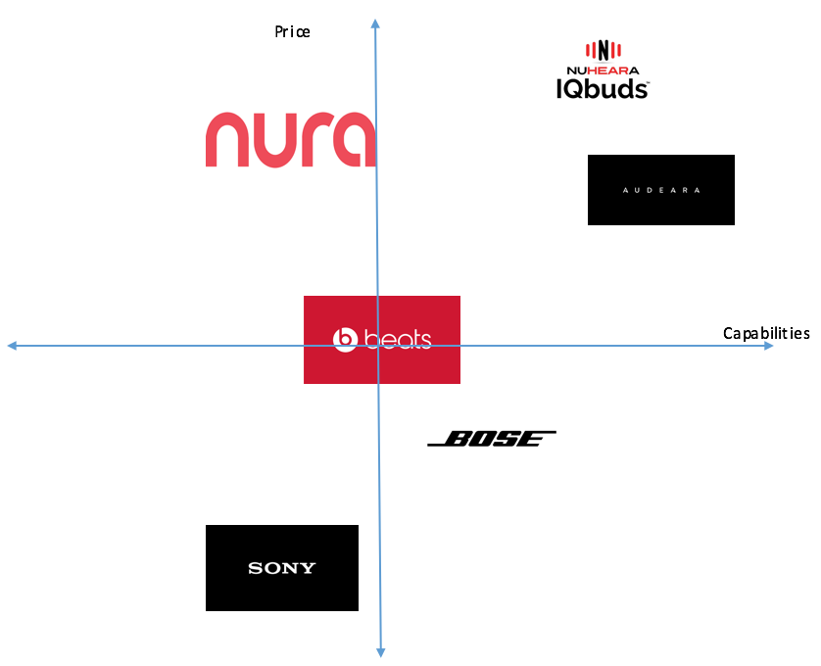

**5.0. Marketing strategies /Recommendations - Haley (need to incorporate the theories from lectures)**

**5.1. Positioning**

As previously mentioned, Audeara are focussed on product differentiation as this is where their competitive advantage lies. In order for differentiation strategies to be successful, it should generate customer value, provide perceived value, and be difficult to copy **(source 1)**. To answer the question ‘does this source of differentiation generate customer value?’, the organisation may consider if the point of differentiation changes the customer’s experience or intention of buying or using the product. According to **(source 2)**, one of the main advantages and reasoning behind the purchase of over ear headphones is the potential for better sound quality and noise cancelling capabilities. Audeara have checked these boxes, with their headphones designed to tailor sound for better quality and the additional attribute of noise cancelling capabilities. Therefore, when asking the question ‘does the product provide the perceived value?’, Audeara can answer that they have done this and more, with the additional attribute of protection from hearing loss. Finally, when asking the question ‘is it difficult to copy?’, the answer for Audeara will be yes - the are the world’s first full fidelity headphones with inbuilt hearing tests for tailored sound and improved quality of music. Audeara are positioned quite well in the market, as product differentiation positioning strategies rely on performance quality for differentiation and competitive advantage. Therefore, it is recommended that they continue to generate a focus on their product attributes of tailored sound and hearing loss protection in their positioning strategy.

SOURCE1: <https://books.google.com.au/books?id=WeeFSyi0FJkC&pg=PT138&lpg=PT138&dq=A+successful+differentiation+strategy+should+generate+customer+value,+provide+perceived+value+and+be+difficult+to+copy&source=bl&ots=5qvQJw6tXM&sig=lPPNbLt3WKTL8idUtqMFGVcy8ho&hl=en&sa=X&ved=2ahUKEwiw4dv61-zdAhX7HzQIHdOPBKcQ6AEwAHoECAkQAQ#v=onepage&q&f=false>

SOURCE2:

<http://www.audiogurus.com/learn/headphones/in-ear-on-ear-over-ear-headphones/208>

**5.2. Building Awareness and Trust**

Though their products are positioned well, the general health issue of hearing loss may not be in the forefront of the minds of university students. Audeara need to consider how to get the importance of this issue across to their target market and other consumers as a supporting marketing tool for their product. As previously mentioned, Audeara is also one of the disability service providers under the National Disability Insurance Scheme (NDIS), and they are also in a partnership with Attune hearing. Audeara may consider utilising these resources to build a marketing scheme to increase awareness of this issue, how it affects everyone and young people in particular, and how their products can be beneficial to the prevention of hearing loss. When positioning their products in relation to this issue, Audeara may stress just how much a young person's hearing can be affected by regular attendance at concerts and music festivals, going clubbing on the weekends, listening to music through headphones on full volume, and other loud environments that they may be exposed to. This may be done through infographics and informational and promotional videos online through sponsored posts on social media, or even on television (though these options may come at a price).

In order for Audeara to increase brand awareness, they need to increase brand and product exposure among their target market of university students. In 2018, Audeara went to the music festival ‘Splendour in the Grass’ to push their product. They were also present at BigSound in 2017 and 2018 as a part of the music technology showcase. We believe that continuing to go to similar events will help to increase consumer awareness within their target market. In order to allow for the consumers to gain trust in the product, we propose that Audeara consider setting up a testing booth. This will allow passers-by to test their hearing and hear how the headphones compliment their hearing profile, thus increasing likelihood of purchase. We also recommend that Audeara consider utilising the testing booths at university open days as this will allow for direct exposure between their target market and the product.

Our final recommendation to build awareness is to expand distribution to physical stores, namely, JB Hi-Fi. This exposes consumers to Audeara next to their competing brands, thus allowing for potential customers to compare the specifications and see the additional benefits that the company offers and supporting the product differentiation strategy. Furthermore, according to **(source 1)** from Forbes, testing the fit and comfort of headphones is crucial to the likelihood of purchase for consumers. With an exclusive online availability, potential customers are not currently able to test these key features, thus a physical distribution channel may increase the likelihood of purchase. Headphones are a costly purchase, and the ability to test the physical aspects of the product may determine whether potential customers decide to make the purchase.

**SOURCE1: https://www.forbes.com/sites/geoffreymorrison/2015/03/16/dont-buy-new-headphones-before-you-read-this/#cc4a6ff4fd3e**

**5.3. Attracting**

After determining the positioning of the brand and building greater awareness, Audeara need to consider how they can make their products more attractive to appeal to university students. One major selling point for university students is price. We strongly believe that offering a 10% discount will make university students more likely to purchase Audeara headphones. This could be done through partnership with websites such as ‘UNIDAYS’, as these websites send direct information on brands with discounts through emails to their subscribed university students and customers. To further offset this concern, we also recommend that Audeara partners with and introduces Afterpay to their online store. We believe that the ability for students to ‘buy now and pay later’ will increase willingness to purchase a product that may be out of the budget, but otherwise appealing.

The current appearance of the headphones is quite generic: all black with leather cushioning around the over-ear speaker. We believe that university students will find appeal in a larger range of colours, textures and sizes. Our client from Audeara has asked to keep away from a ‘trendy’ brand personality and lean more towards an aura of sophistication. **(source 1)** identifies black, white, and grey to be colours associated with brand the personality traits of sophistication and timelessness. Therefore, it is recommended that Audeara start to expand their product line with headphones in these colours, perhaps adding more as the brand gains traction.

**Source:** http://www.ignytebrands.com/the-psychology-of-color-in-branding/

**6.0. Budget. - John**

**Figure 1.1**

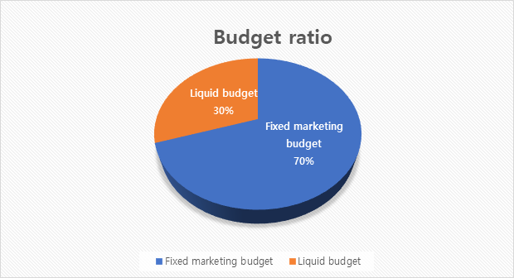

The budget has been decided by many factors the internal and external environment, as well as the recommendations that have been suggested. The recommended marketing budget is a ratio of 70:30 - 70% for fixed marketing expenditure, and 30% for liquid assets. The fixed budget is the amount that is designated to cover the recommendations. This fixed budget is not affected by other factors. The liquid budget is essentially the spare budget. This is in place to ensure that throughout the implementation of the recommendations, Audeara are ready for other marketing and business needs or emergency situations.

With the exception of the liquid budget, the assigned fixed marketing budget has been constructed with consideration of the various project recommendations and internal and external factors. There are 5 areas to focus on and consider for the budget. Firstly, social media advertising is one of the main focuses for our recommendations with the use of infographics and sponsored posts in partnership with NDIS. Therefore, 30% of budget will be dedicated to this. Testing booths are another focus of our recommendations, and they will be utilised to build consumer awareness and trust at events frequented by the target market. This recommendation will also occupy 25% of the marketing budget. Physical distribution will also be used to help build brand trust and awareness. 20% of the fixed marketing budget should be dedicated to this. Experimentation with design (i.e. colour, texture, general fit, size etc.) will be used to attract customers, however, it is not the main focus of our plan. Therefore, it will occupy 15% of the budget. Finally, partnerships with brands such as ‘UNIDAYS’ and ‘afterpay’ for discounts and other cost-friendly features will be dedicated 10% of the fixed marketing budget.

**7.0. Implementation Plan. - John**

In order to implement the recommendations, Audeara should take the following steps. First and foremost, they should introduce the 10% student discount through UNIDAYS as well as the use of afterpay online. This will ensure that any traffic that is already existent in their online store may be more inclined to purchase and become customers.

Next, Audeara should focus on building awareness of the issue of hearing loss through the design and release the sponsored social media infographics and informational promotional videos. This will help to get the message across to their target market of university students, and stress the importance of hearing loss and the impact that it may have on the lives of young people.

To build further awareness and trust for the actual product, Audeara should then continue to participate in music festivals such as ‘Splendour in the Grass’, and utilise the testing booth to ensure that any uncertainties the target market has about the brand or the product itself can be eradicated as they test their hearing and see how the headphones compliment testers hearing profile. Audeara should also attend any university open days to directly engage with their target of university students. After participating in these activities, Audeara may consider utilising physical distribution through stores such as JB Hi-Fi. This will build more trust and awareness for their brand and product, allowing consumers to test the fit and the ability of the headphones. This may be beneficial in attracting a larger range of people, not just t university students.

Finally, after the previous steps have been achieved, Audeara may wish to advance the current appearance of the headphones. Because Audeara would like to keep their brand personality sophisticated, they could potentially start with bringing in colours that project this tone such as white and grey. After this, they may wish to consult with their consumers, and discover other ways to personalise the headphones.

**8.0. Limitations. - John**

There are three main limitations to the recommendations we have suggested for Audeara.

The first limitation is existing market share. The market is already largely dominated by big brand competitors with exceptional brand awareness and trust. Audeara may struggle to gain a large share of the market even with the implementation of our recommendations. Though Audeara have the competitive advantage through differentiation and quality, the other brands also have their own rare capabilities and specialty knowledge.

The second limitation is price acceptance. Product price is an important component of consumers purchase intention. Even with the recommended discount for students, it is possible that they may still see the price as too high.

Finally, the third limitation is uncertainty. As Audeara is a new company with a new idea related to hearing health, it is difficult to predict the demand for their product. It is possible to use other companies as benchmarks, however, this may be difficult or inaccurate as other companies have different brand images, attract different consumers, have different product capabilities, use different marketing techniques, and so on.

**9.0. Conclusion / Summary of key recommendations.**

To sum up, Audeara is a start up business who is looking to increase their profit margin by expanding their target market. By evaluating the situational analysis, we found a gap in Audera’s marketing strategies. Audera’s current market is the older generation, who already have trouble with their hearing. Therefore, we wanted to go to the root of the existence, before it even came a problem. We believed by targeting millennial university students this will help Audeara increase their revenues as well as prolong the hearing of generations to come. The following recommendations have been made to engage with university students; collaborating with my unidays and JB HI FI, offering afterpay as well as to set up testing booths in music festivals to increase brand awareness.

**10.0. References.**

Any information that you have taken from other sources should be referenced, including your client’s website and pictures. Otherwise this is Plagiarism (or intellectual theft to put it bluntly). Theft of proprietary material (especially if you are passing it off as your own ideas) has serious consequences in the commercial world and can lead to large lawsuits so don’t get into this habit. Include a citation in the body of the report and a full reference in this section. For diagrams, figures or tables put: *Source: then the citation*. Use Harvard or APA style. It doesn’t matter which but stick to one style and keep is consistent throughout the report. There is no minimum number of references required but I would be surprised if you didn’t include any.

**Mikey:**

Quote from review:<https://www.techradar.com/au/reviews/audeara-a-01-review>

<https://audeara.com/pages/about>

In ear vs On ear vs Over ear market share:

<https://www.businesswire.com/news/home/20161229005052/en/Rapid-Growth-Sports-Headphones-Drive-Headphones-Market>

US wireless market:

Richter, F., Mr. (2017, February 8). The U.S. Wireless Headphone Market. Retrieved August 18, 2018, from<https://www.statista.com/chart/7993/headphone-market-share/>

**11.0. Appendices.**

These should be included to provide background or backup material that provides further evidence of what you are saying in the report. If it is important and will add to the story you are telling you should include it in the body of the report. If not, or it is distracting to the flow of your argument, include it as an appendix.

Appendix 1:



|  |  |  |  |  | |  |  |  |  |
| --- | --- | --- | --- | --- | --- | --- | --- | --- | --- |
|  |  |  |  |  |  |  |  |  |  |
|  |  |  |  |  |  |  |  |  |  |
|  |  |  |  |  |  |  |  |  |  |
|  |  |  |  |  |  |  |  |  |  |
|  |  |  |  |  |  |  |  |  |  |
|  |  |  |  |  |  |  |  |  |  |
|  |  |  |  |  |  |  |  |  |  |
|  |  |  |  |  |  |  |  |  |  |
|  |  |  |  |  |  |  |  |  |  |